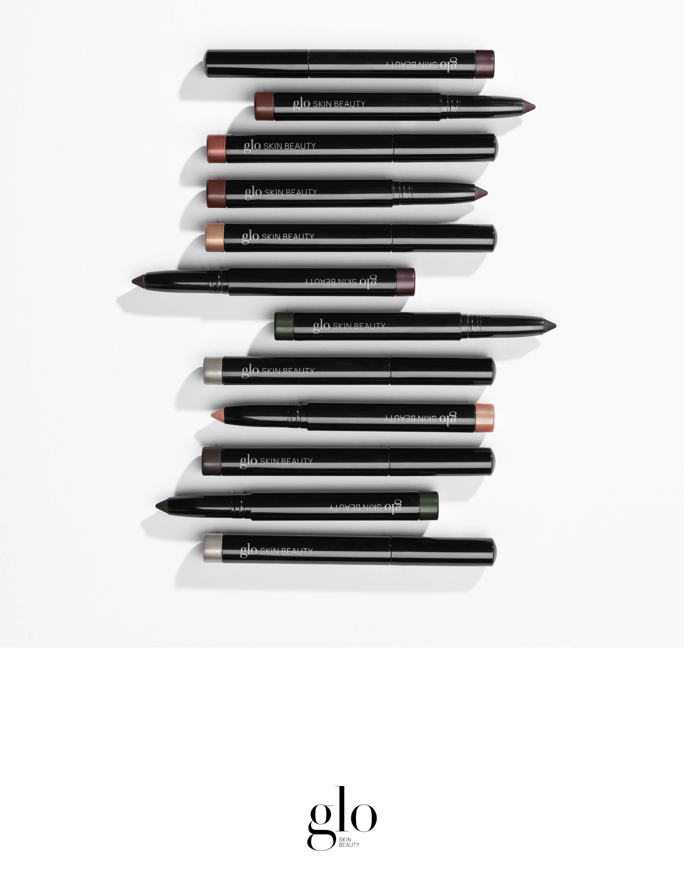
Cream Stay Shadow Stick – 6 NEW shades!
December 1, 2018
Event info. Event info. Event info. Event info. Event info. Event info. Event info. Event info. Event info. Event info. Event info. Event info. Event info. Event info. Event info. Event info. Event info. Event info. Event info. Event info. Event info. Event info. Event info. Event info. Event info. Event info. Event info.

